Is Funding Charter Schools a ‘Slap in the face of disabled children’?

Recently the Associate Education Minister David Seymour announced $153 million had been set aside for 15 new charter schools and to convert 35 state schools into charter schools.

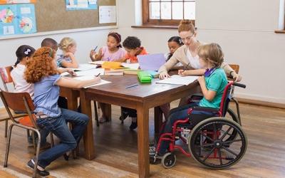
This announcement has been met with dismay by many parents with disabled children who struggle to receive enough support for their disabled children at school. Mark Potter president of NZ Educational Institute (NZEI) said ‘the $153m could pay for 700 full time teacher assistants across the country’. This would go some way to closing the gap between the support currently provided for disabled children’s education and that which is needed. The NZEI estimate it would cost $60,000 a student per year in charter schools compared to $9000 a student per year in state schools.

Others would argue that charter schools provide an opportunity for disabled students to receive an education in a more suitable environment. Or would this increase the isolation and marginalisation of disabled people?

According to Labour, charter schools are a failed experiment and should not be revisited. Others believe the money saved reducing the school lunches programme budget is helping fund charter schools, robbing one large, disadvantaged group to help pay for a failed experiment.

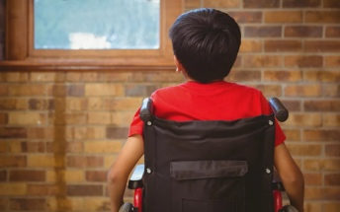
The government hasn’t yet shared their intentions for charter schools. There is very little detail about who these schools would cater for, whether they would follow the New Zealand curriculum and be subject to the same teaching standards as state schools. This makes it hard to judge whether this is a reasonable move or not.
Whatever your view on charter schools, is the fact remains that the education system is not resourced adequately to meet the education needs of disabled students.

For more on charter schools check out The Press for Maddy Croad’s article In the Education section, Friday 17 May 2024.

https://www.thepress.co.nz/nz-news/350278604/charter-school-funding-slap-face-disabled-children-mum-says

